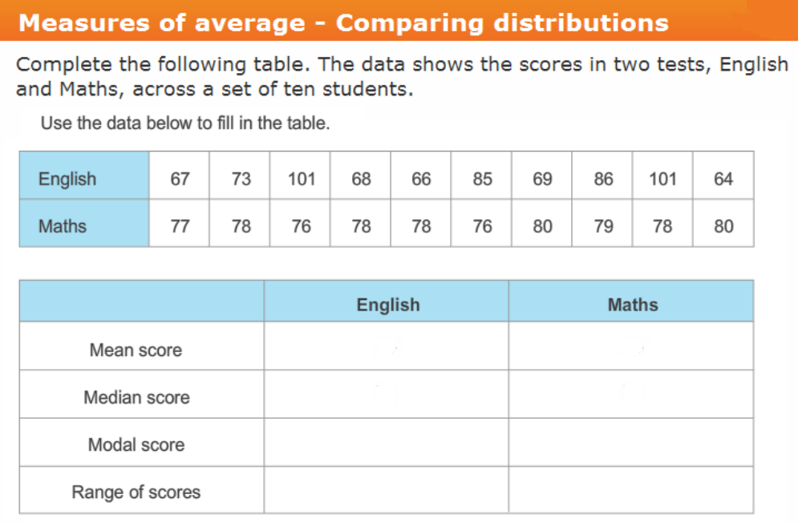
In the space below, compare each measure of average for English and Maths. Include the actual number as evidence to your statement.

Range of scores:

Mean score:

Median score:

Modal score:

If you were to compare the scores in the two subjects, English and Maths, which subject were students better at? (Use evidence to support your choice)

